**IGME-760-01 ONLINE**

**AI for Gameplay**

**Fall 2018 Course Syllabus**

**REMINDER: The information presented in this syllabus is subject to expansion, change, or modification during the semester**

|  |  |
| --- | --- |
| Instructor: Prof. Kevin Bierre  **Email:** [kjbics@rit.edu](mailto:kjbics@rit.edu)  **Home Phone:** 386-638-0164**  **Skype:** kbierre6 | **Office:** In my house in Florida*  Office Hours: M 5 - 8 PM, T 6:30 – 8 PM  (Online via Skype or email), and other times by appointment |

* - No, this is not an invitation to drop by.

** - This is my home phone number, so I would suggest you think carefully before you call me at home. Calls should be limited to emergencies such as a major family emergency, sudden illness, or the like. Problems with an assignment or project are NOT emergencies and should be handled via email or Skype.

Course Texts and Materials

1. *Artificial Intelligence for Games, Second Edition* by Millington and Funge, CRC Press, 2009
2. Unity or other **free** game development environment like Unreal, etc.

**Note that this is an online course. We do have a lab assigned to us, but that is available for your teams to work on your projects. I will not be using the lab to deliver course material, that will be done entirely online via the recorded lectures.**

Important RIT Deadlines

Last day of add/drop is September 4, 2018.

Last day to withdraw with a grade of “W” is November 9, 2018. Withdrawals are done online. See the Student Services office for information on how this process works.

NOTE: IGM department policy states that a student has one semester to challenge any grade. After that, grades cannot be challenged.

Course Description

This course explores introductory artificial intelligence concepts through both a theoretical and practical perspective, with an emphasis on how to apply these concepts in a game development context.  In particular the course focuses on applying concepts such as search, reactive intelligence, knowledge representation, and machine learning to real-time situations and applications as relevant to the field of entertainment technology and simulation. (Prerequisites: IGME-309 or equivalent course and student standing in GAMEDES-BS.)

**Course Objectives**

**General**: The goal of this course is to cover a variety of artificial intelligence techniques that are applicable to games. (There is a big difference between academic AI and the more pragmatic approach to AI that is taken by game developers.) We will look into the following topics: movement, pathfinding, decision making, tactical/strategic AI, game theory approaches to decisions, and some machine learning. Teamwork is also emphasized in this course through the implementation of multiple projects by small student teams.

**Specific**:

* Students will be able to implement select AI techniques to solve problems commonly seen in games.
* Students will be able to examine AI techniques and be able to select the best approach for a given problem.
* Students will be able to critically look at game related AI research or implementation articles and report on them.

**Prerequisites:**

* Successful completion of DSA2
* Being a student in the GDD program

**Role of course in curriculum for:**

IGM: This course is an advanced elective for GDD students

Organization

In a given week there will be multiple lectures posted online. These lectures are organized by week under the Content section of MyCourses.

Along with the lectures there will be weekly discussion questions. Most of these assignments are fairly short and can be completed in about an hour or less.

There will also be project assignments. These programs will require more work and serve to reinforce course concepts.

***Technical Support:***

There is technical support available for this course:

If the issue is missing material, I will be the best choice for contact via email. In all likelihood, the material may be set for a timed release or was not uploaded properly. While I try to check everything, sometimes loading issues do occur.

If you are having issues using your MyCourse account, contact [tlsupport@rit.edu](mailto:tlsupport@rit.edu) or call the ITS help desk at 585-475-HELP (4357) or 585-475-2810 TTY.

## Assignment Submissions:

Projects must be submitted to MyCourses as a single .ZIP file containing all of your files, since there will usually be more than one. Do not email me your work.

You may re-submit any deliverable files as many times as you want (for example, if you find an error after submitting) up until the dropbox close date. **Only the most recent one will be graded.**

***Late Work on Assignments:***

This one is fairly straight forward: **DON’T BE LATE**. If you miss the closing of the dropbox, you get a zero. (Note: If there are issues with illness or family emergencies, you need to contact me **PRIOR** to when the assignment is due. (If the issue is that you can’t tell time or like to procrastinate, you are out of luck.)

If you are not certain you can get the entire assignment completed by the deadline, it’s better to submit partially completed work and get a lower grade than to miss the deadline and get a zero. (Yes, I do give partial credit based on how much of the assignment you were able to finish successfully even if the entire thing isn’t working.)

This policy covers discussion work and project milestones.

***Early Work on Assignments:***

It’s OK to submit your work early. If you want to get ahead in the course, I think that’s great. However, even if your work is early, it will be graded along with all of the other assignments after the dropbox closes. So please don’t start asking what your grade is on an assignment until about a week after the dropbox closes.

***Assignment Grading:***

As a general policy, I try for a one week turn around on assignment grades. That means you should see your grade for an assignment no later than a week **after the due date**.

## Project Assignments:

Programming assignments are an integral part of this course. There will be 5 project assignments this semester.

**No project work will be accepted after the last day of regular classes for the semester.**

You are required to be an active participant in the project. Failure to do so will have a major effect on your final grade. I do not tolerate slackers on a team and neither should you. There will be anonymous peer evaluations at several points during the semester. I will be paying close attention to each group. **Failure to be an active participant in the project may lead to you being “fired” from the team and having to do the remaining project assignments all by yourself.**

## Discussion Questions:

There will be weekly discussion questions. Topics and format of these questions will vary. In most cases, I will pose a question and ask for a response from everyone. Then you will look over your classmates’ responses and comment on an assigned number of them. For other discussions, I may ask you to look up and summarize some current AI research or some game AI implementation work. Your classmates will then comment on it.

The initial post will usually be required by the end of the day on Wednesday, with any follow up comments due by the end of the day on Saturday.

I require that discussion posts have been proofread and are grammatically correct. Comments on other’s posts must address the topic at hand. Comments like “Hey bro, like your post!” are not going to be considered a useful comment on someone else’s post.

Just a final note on discussions: A lot of people lost points last year by not participating in the discussions. I do read the discussions and track who is actively participating.

**Grading**

The course grading criteria and grading scale are as follows:

|  |  |  |  |  |  |
| --- | --- | --- | --- | --- | --- |
| Grade | Low | High | Grade | Low | High |
| A | 95 | 100+ | C+ | 76.67 | 79.99 |
| A- | 90 | 94.99 | C | 73.34 | 76.66 |
| B+ | 86.67 | 89.99 | C- | 70 | 73.33 |
| B | 83.34 | 86.66 | D | 60 | 69.99 |
| B- | 80 | 83.33 | F | 0 | 59.99 |

|  |  |
| --- | --- |
| **Component** | **Weight** |
| Discussion Questions | 30% |
| Project Assignments | 70% |

**Grading Notes:**

|  |
| --- |
| **Rounding of Final Grades**  Your grade is the actual grade, there is no rounding. If your grade is 59.99, it is an F. |

**IGME-760 Fall 2018 Schedule**

|  |  |  |  |
| --- | --- | --- | --- |
| Week | Topics | Readings | Assignments |
| 1 | Course Intro, Game AI vs. Academic AI | Ch. 1 and 2 | Group survey, Meet your team, Environment design planning,  Discussion 1 |
| 2 | Movement | Ch. 3.1-3.3 | Environment design submission, Start project 1, Discussion 2 |
| 3 | Movement | Ch. 3.4, 3.5 | Discussion 3 |
| 4 | Movement | Ch. 3.7, 3.8 | Project 1 Due, Start Project 2, Discussion 4 |
| 5 | Pathfinding | Ch. 4.1-4.3 | Discussion 5 |
| 6 | Pathfinding | Ch. 4.4-4.5 | Discussion 6 |
| 7 | Pathfinding | Ch. 4.6-4.9 | Project 2 Due, Start Project 3, Discussion 7 |
| 8 | Decision Making | Ch. 5.1-5.6 | Discussion 8 |
|  | SPRING BREAK |  |  |
| 9 | Decision Making | Ch. 5.7-5.11 | Project 3 Due, Start Project 4, Discussion 9 |
| 10 | Tactical and Strategic AI | Ch. 6.1-6.2 | Discussion 10 |
| 11 | Tactical and Strategic AI | Ch. 6.3-6.4 | Discussion 11 |
| 12 | Board Games/Game Theory | Ch. 8.1-8.7 | Project 4 Due, Start Final Project, Discussion 12 |
| 13 | Learning | Ch. 7.1-7.4 | Discussion 13 |
| 14 | Learning | Ch. 7.5-7.8 | Discussion 14 |
| 15 | Finals |  | Final Project Due |

# Additional Policies:

### Late Policy:

If you are having problems with an assignment or an emergency that may make you late in submitting your work, **contact me before the due date**. Excuses made after the fact will not be honored.

### Final Exam Date:

There is NO final exam in this course. Your final project submission is your final.

### Contact Information:

Any updates to assignments and any emails that I need to send to individual students will be done through MyCourses. **What this means is that you should check your RIT email and the MyCourses conference for this course periodically.**

## Policy on W and I Grades

RIT policy allows you to withdraw from a course with a grade of **W** on or before the Friday of the eleventh week in the semester. After this date, your instructor cannot give you a **W**, but must assign you a grade based on your work.

This course has been designed so that you can complete all the work in one semester. Thus incomplete grades will be given only in the most exceptional circumstances, and then only by *prior* arrangement with your lecture instructor. I only give incomplete grades if you are being deployed by the military or you have a personal or family emergency that has been verified by the Dean of Students. **Failure to complete the required course work is NOT a reason to receive an incomplete.**

**Extra Credit:**

I don’t offer extra credit assignments. Don’t ask for one. If you want to do well in this course, do the assigned work well and submit it on time.

### What Do You Call Your Professor?

That generally is up to the professor. They will often give you an indication of what is acceptable. Here’s my indication: you can call me “Professor” or “Professor Bierre”. Calling me by my first name, last name, or “Hey you” falls under the heading of a “bad idea”. (And “Brofessor” is a “very, very bad idea”.)

**Social Networks:**

I don’t respond to friend requests from students on Facebook or any other social networking application. This is primarily to preserve my sanity. I do not need to hear about your latest romantic crisis, the fact that you have just discovered that you have a zit the size of Mount Everest on your forehead, or all of the reasons that your AI professor is evil. (In case you are wondering, I am evil. It used to bother me, but I quickly got over it.)

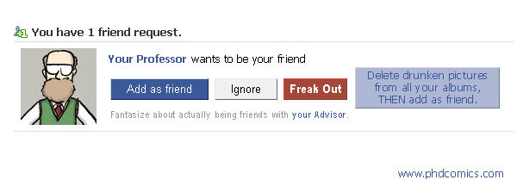

I wouldn’t hold my breath waiting for this to happen either.

### Academic Dishonesty:

People have been caught cheating on assignments in some of my courses in the past. My policy on dishonesty is simple**: If you get caught cheating, you are history. You get an “F” as a grade, a letter detailing the incident goes into your folder, and you are immediately removed from the section.**

Note that if you get accused of cheating, the evidence has already been checked by at least two other faculty members to verify it. I do use tools like “Measure of Software Similarity” (MOSS) to compare assignments.

Please review the departmental policy on cheating as described on the last page of the syllabus.

**If you do your own work and don’t share code, then you won’t have anything to worry about regarding academic dishonesty.**

**Finally...**

Any or all of the previous information is subject to change or modification during the semester. Have fun!

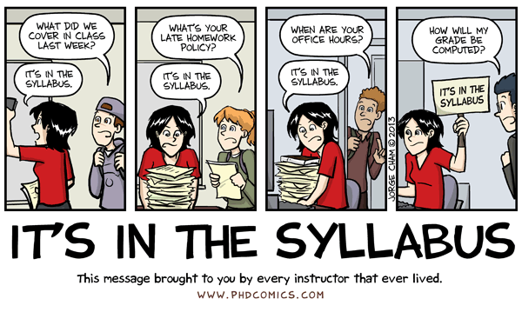

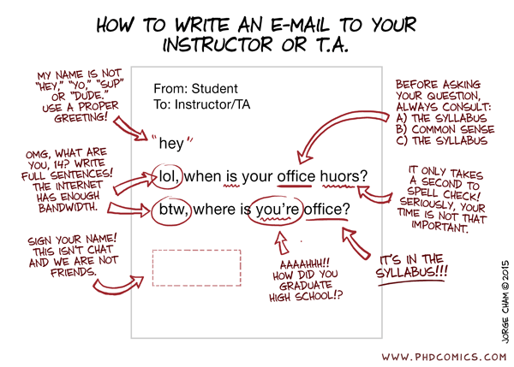**ACADEMIC DISHONESTY POLICY**

**SCHOOL OF INTERACTIVE GAMES AND MEDIA**

The following statement is the Policy on Academic Dishonesty for the Department of Interactive Games and Media:

The Department of Interactive Games and Media does not condone any form of academic dishonesty. Any act of improperly representing another person’s work as one’s own (or allowing someone else to represent your work as their own) is construed as an act of aca­demic dishonesty. These acts include, but are not limited to, plagiarism in any form or use of information and materials not authorized by the instructor during an examination or for any assignment.

If a faculty member judges a student to be guilty of any form of academic dishonesty, the student will receive a **failing grade for the course**. Academic dishonesty involving the abuse of RIT computing facilities may result in the pursuit of more severe action.

If the student believes the action by the instructor to be incorrect or the penalty too severe, the faculty member will arrange to meet jointly with the student and with the faculty member’s immediate supervisor. If the matter cannot be resolved at this level, an appeal may be made to the GCCIS Academic Conduct Committee.

If the faculty member or the faculty member’s immediate supervisor feels that the alleged misconduct warrants more severe action than failure in the course, the case may be referred to the GCCIS Academic Conduct Committee. The Academic Conduct Committee can recommend further action to the dean of the student’s college including academic suspension or dismissal from the Institute.

The following definitions will be used to clarify and explain unacceptable conduct. This is not intended to be an exhaustive list of specific actions but a reasonable description to guide one’s actions.

CHEATING includes knowingly using, buying, stealing, transporting or soliciting in whole or part the contents of an administered/unadministered test, test key, homework solution, paper, project, software project or computer program, or any other assignment. It also includes using, accessing, altering, or gaining entry to information held in a computer account or disk owned by another.

COLLUSION means the unauthorized collaboration with another person in preparing written work or computer work (including electronic media) offered for credit. Final work submitted by a student must be substantially the work of that student. Collaboration on an assignment is expressly forbidden unless it is explicitly designated as a group project. When there is any doubt, a student should consult the instructor (NOT ANOTHER STUDENT) as to whether some action is considered collusion.

Whenever there is any question as to whether a particular action is considered academic dishonesty, the instructor should be consulted.

The penalty for academic dishonesty in a course is an automatic “F” in that course.